1.Model trefla simpla:

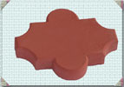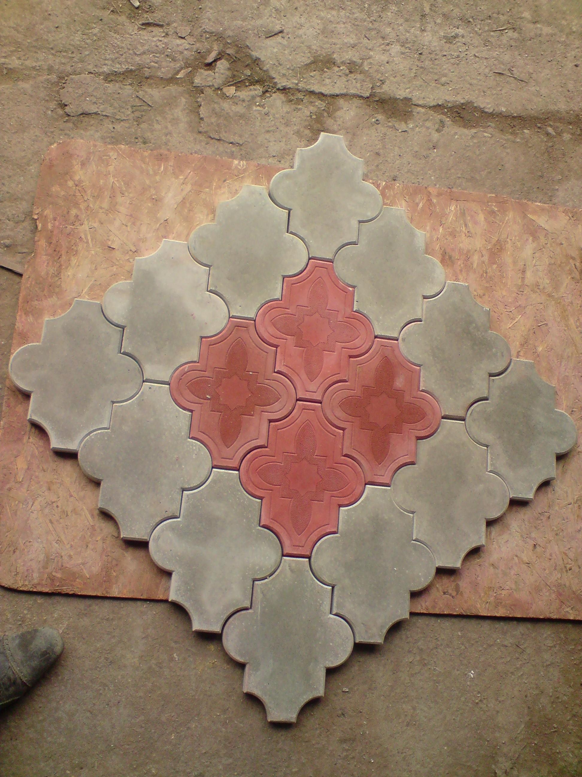

Grosimi
h=2.5 –acces pietonal
h=4.5 –acces trafic mediu <7 tone
h=6.0 –acces trafic greu > 7 tone

2.Model trefla cu model:

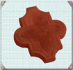

Grosimi
h=2.5 –acces pietonal
h=4.5 –acces trafic mediu <7 tone

3.Model mercedes:
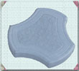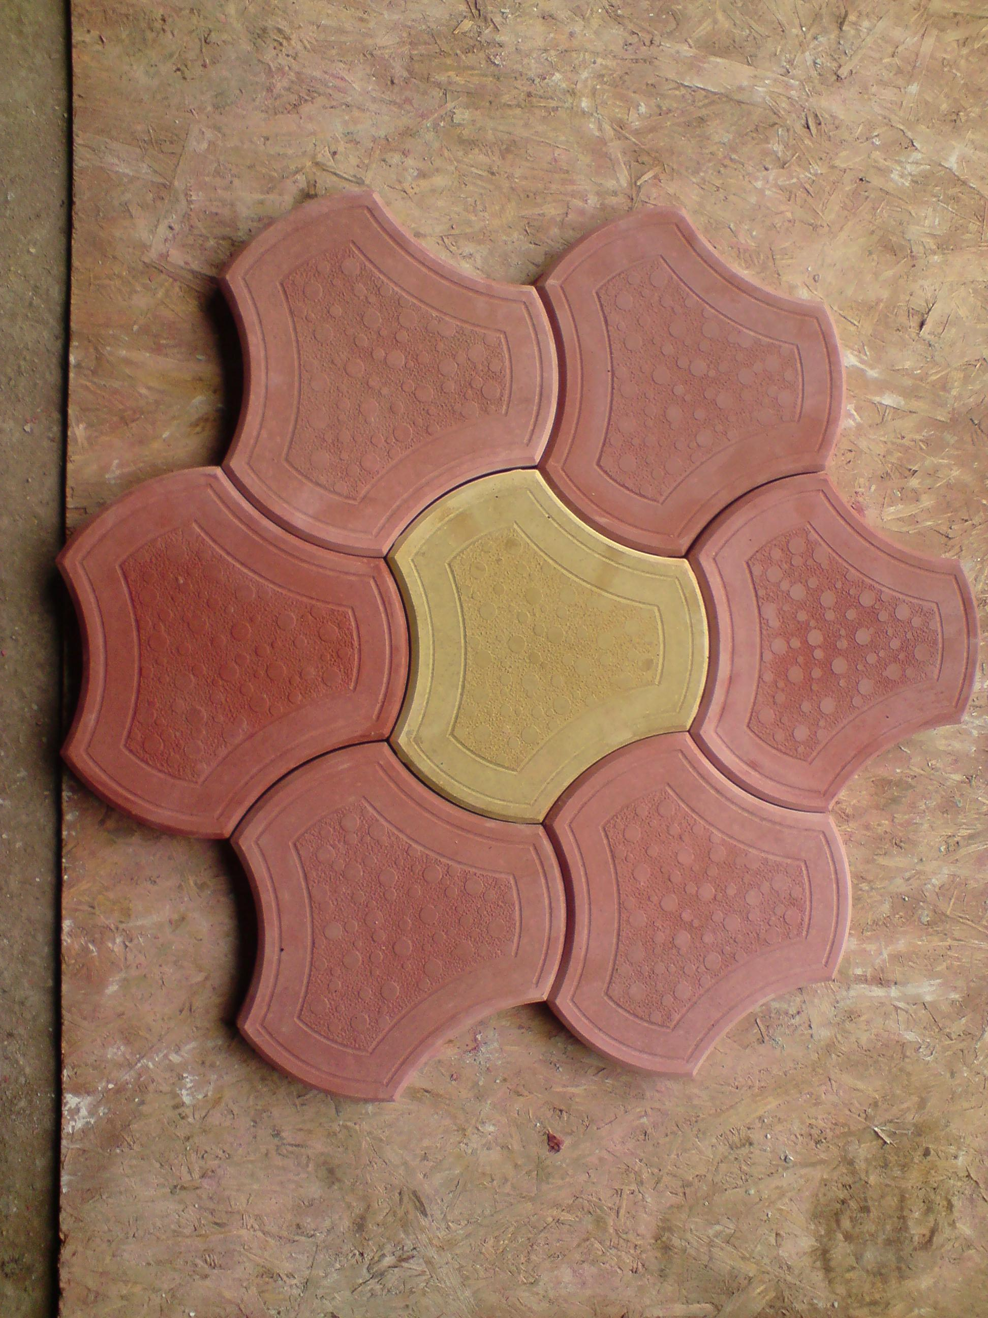

Grosimi
h=4.5 –acces trafic mediu <7 tone

4.Model romb

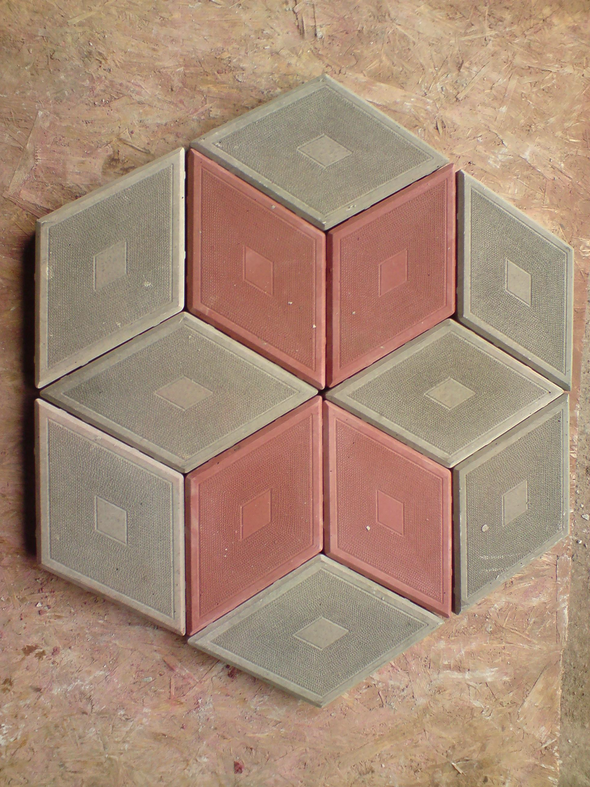

Grosimi
h=4.5 –acces trafic mediu <7 tone

5.Model eko

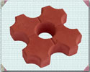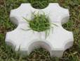

h=6.0—acces trafic mediu

6.Model “I”
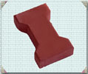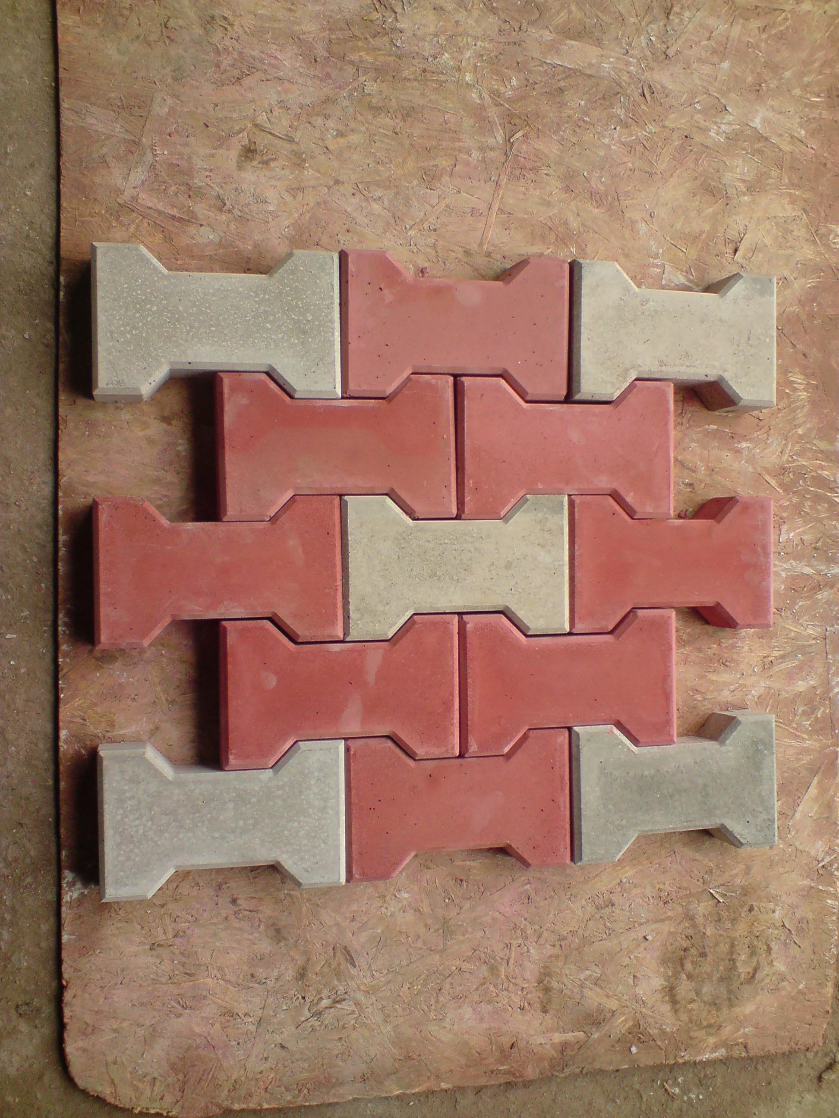
h=6.0 –acces trafic greu > 7 tone

7.Model val

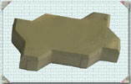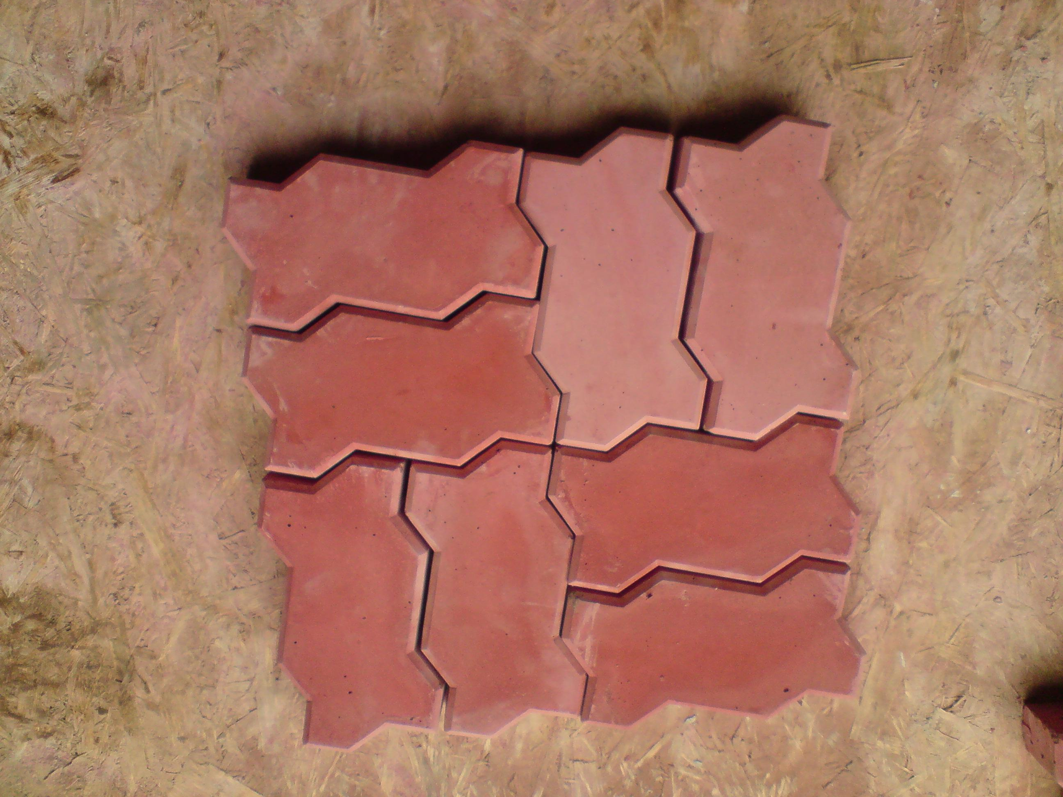

h=6.0 –acces trafic greu > 7 tone

8.Model topor
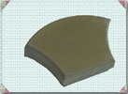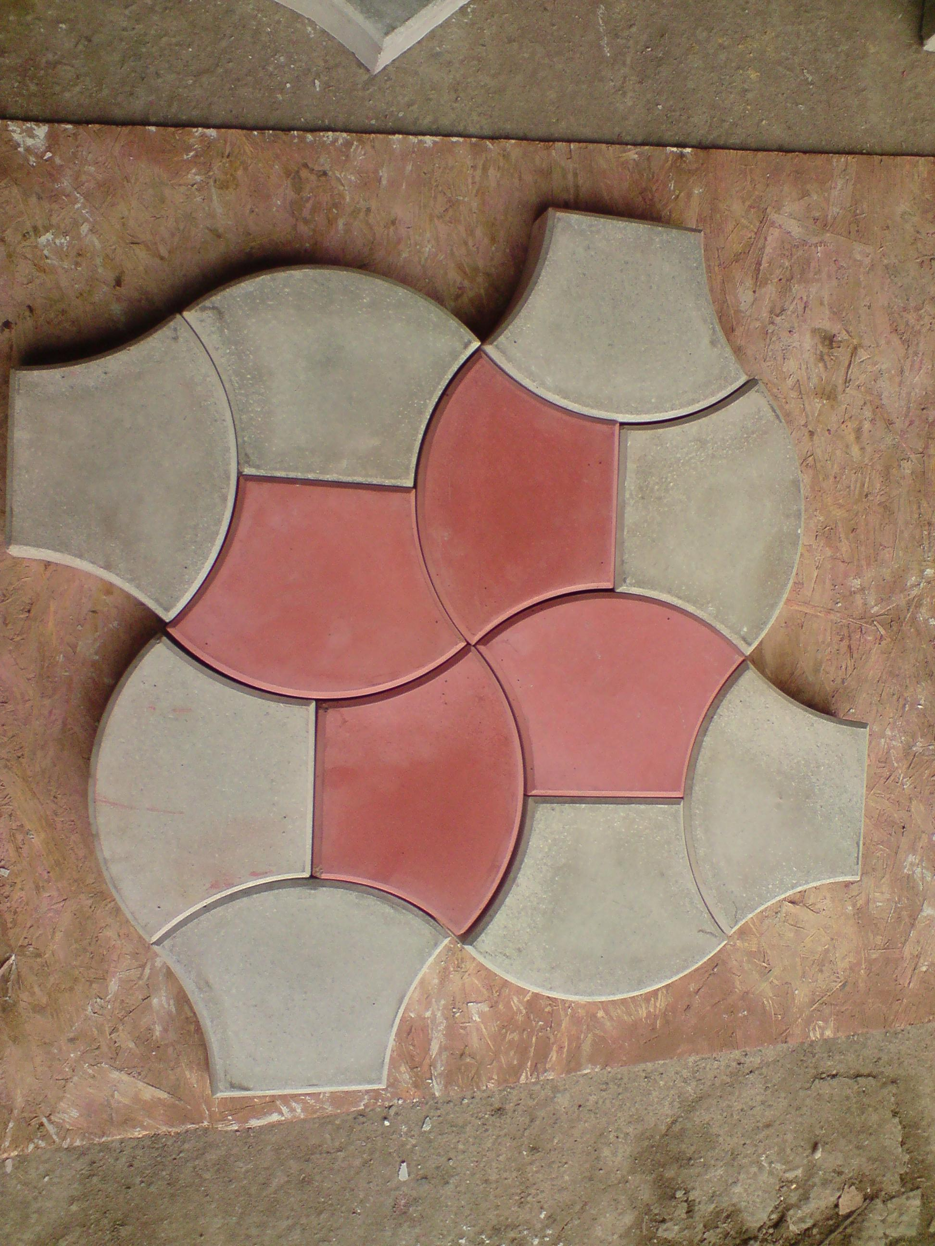
h=6.0 –acces trafic greu > 7 tone

9.Jgheab scurgere
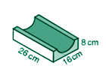

10.Coama stalp 45 x 45
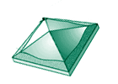

11.Coama stalp 30 x 30

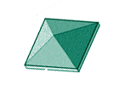

12.Bordura

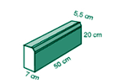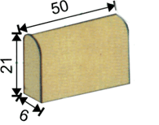

13.Placaj

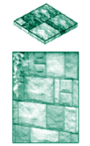

14.Coama gard

